CST 4550 LAB 5.1

1 Run nmap to achieve each of the following scans

* Full Scan

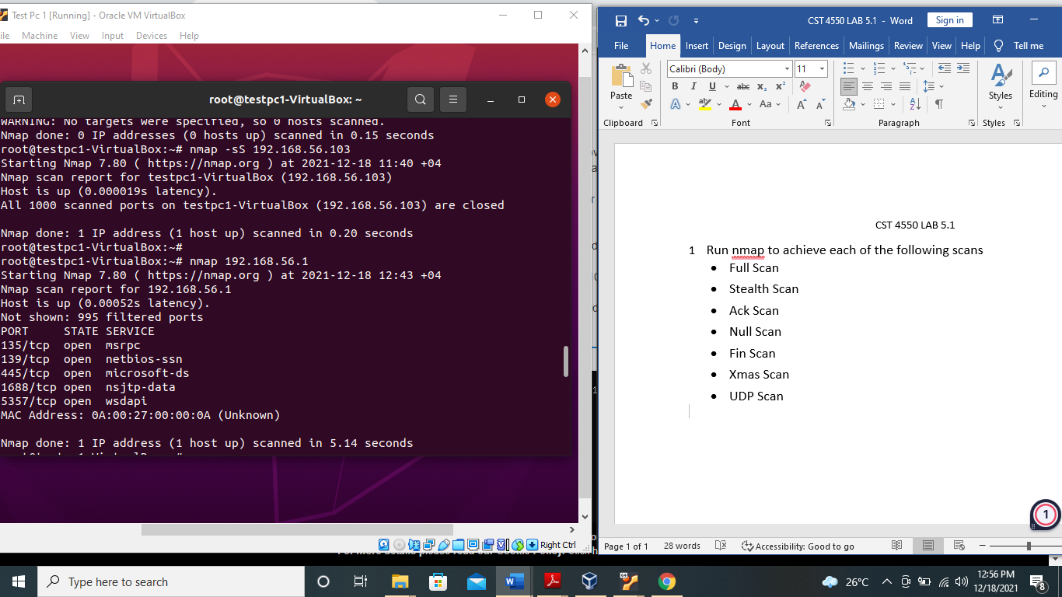

* Stealth Scan

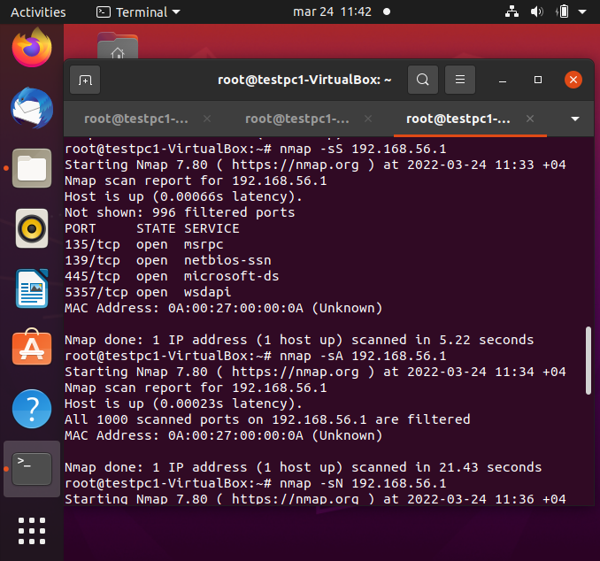

* Ack Scan

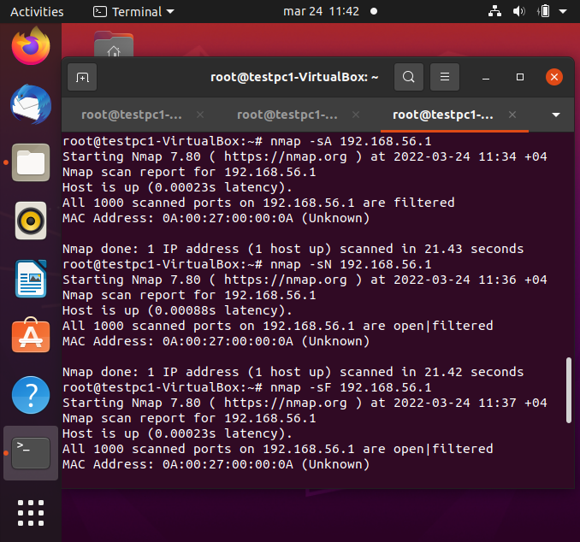

* Null Scan



* Fin Scan 
* Xmas Scan

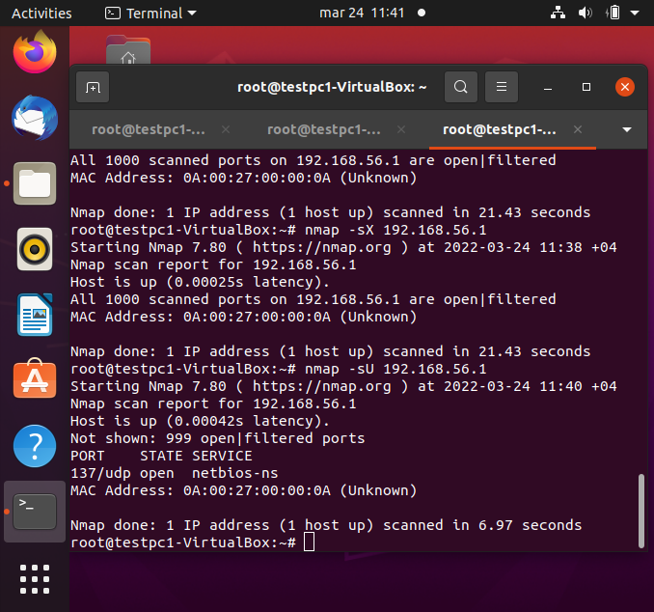

* UDP Scan



Task 2 Idle scan.

1. Run nmap –v –o –sS {zIP}, make a note of the outcome

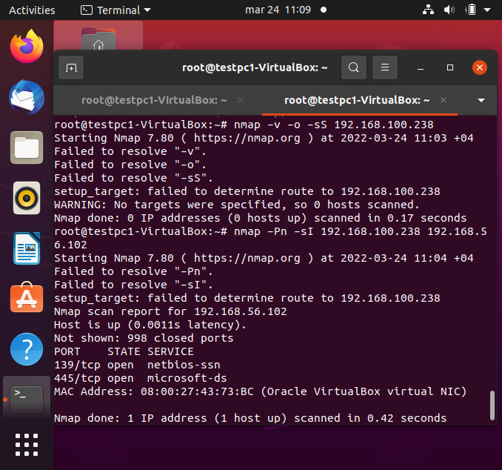

1. Run the following command: nmap –Pn –sI {zIP}{tIP}, make a note of the outcome

